Assessment: Assignment 04

Student Name: Adam Di Cioccio

Lab Professor Name: Mohammad Patoary

Lab Section Number: 321

Due Date: December 8, 2020

# Screenshot of running program

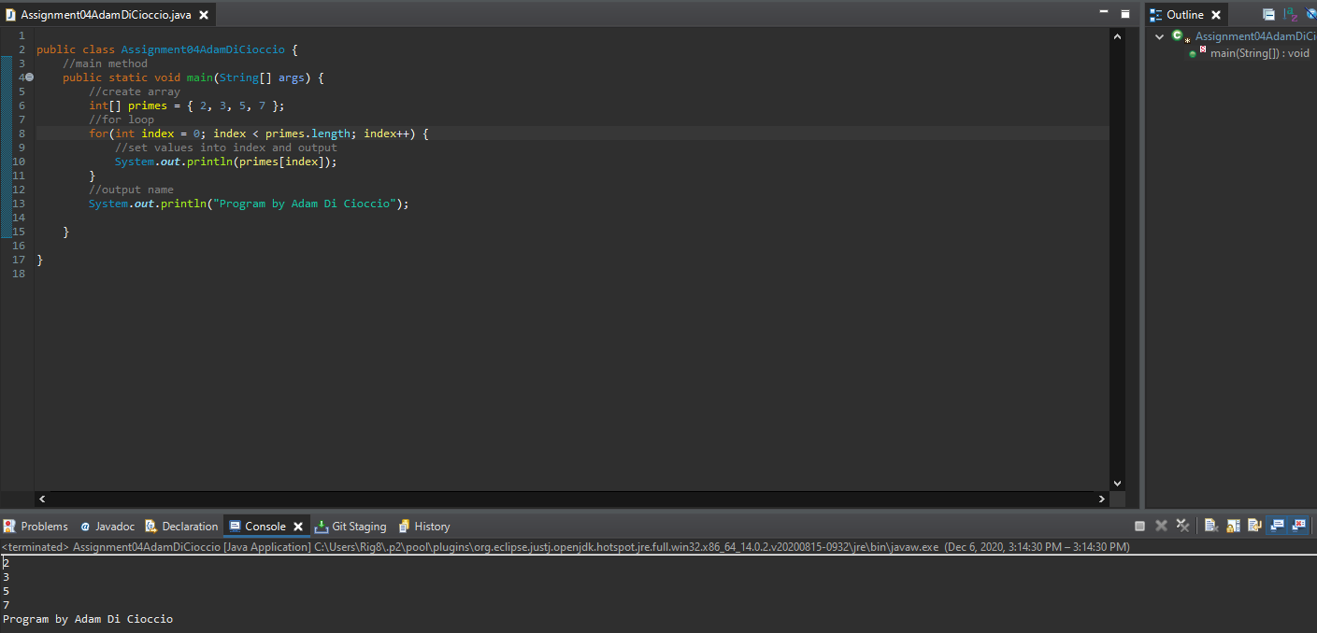

# Screenshot of Git history in Eclipse

